Introduction

In this photo essay I will examine gentrification efforts in Pilsen—a predominantly Mexican and Mexican-American neighborhood in Chicago’s Lower West side. Gentrification efforts have several key consequences. Urban renewal and neighborhood revitalization processes uproot existing residents and displace them from their homes, businesses, and communities, and often foster or amplify marginalization, isolation, and alienation amongst remaining community members. Framing neighborhoods, such as Pilsen, as places in need of change discredits and undermines the sense of community, belonging, and mutual support that many already marginalized, residents of low-income neighborhoods rely on, therefore potentially serving as a seedbed or amplifying a host of social and structural issues, such as further marginalization and deprivation in both a social and an economic sense.
In the first section of this essay, I will introduce gentrification by providing definitions and background on the term. In the second section, I will introduce Mumm’s (2017) framing of gentrification as “a racial fix” in order to discuss the role race and ethnicity plays with regard to gentrification. In the third section, I will introduce Pilsen as the area of focus for this essay and provide a background of Pilsen’s history. In this section I will also provide demographic and income figures to demonstrate the ways in which gentrification and urban redevelopment have transformed Pilsen. In the fourth section, I will discuss the significance and consequences of gentrification in Pilsen, namely in terms of displacement as well as marginalization, isolation, and alienation. In the final section of this essay, I will examine various forms of resistance to gentrification that are employed in Pilsen; I will center this section on the work of activists and grassroots organizations as well as the role of art.
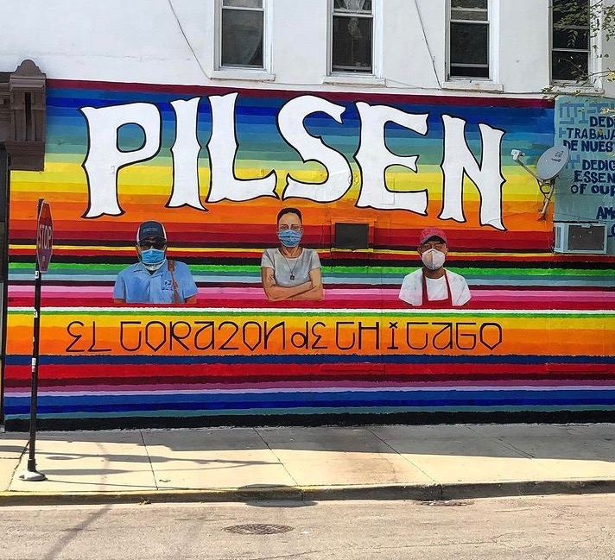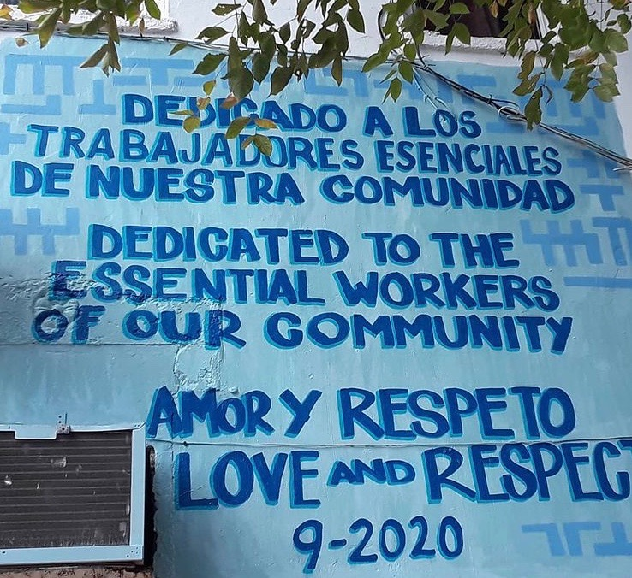
These two images depict a mural “dedicated to the essential workers of [their] community.” Neighborhoods experiencing gentrification are often narrowly characterized as areas in need of change and revitalization and change, neglecting to shine a light on notions of community, solidarity, and unity that characterize these neighborhoods and the individuals residing in them.

Gentrification: Definitions and Background

Hwang & Lin (2016) define gentrification as the process through which a neighborhood with low socioeconomic status experiences increased investment and a subsequent “influx of new residents of higher” socioeconomic status; they highlight further indicators of gentrification as including changes to physical, cultural, as well as demographics characteristics, as well as improvements in amenities and increases in both rents and housing values (p. 10). Bader (2011) states that “after decades of flight from urban neighborhoods, the number of middle-class residents began to slowly increase in some neighborhoods as early as the 1960s and, in some cases, pushed out existing residents” (p. 313). This notion of displacement is central in Ruth Glass’s 1964 definition of gentrification in which she highlights the process by which working-class populations in urban London neighborhoods were displaced by middle-class professionals (Bader, 2011, p. 313).
Highlighting the various stakeholders involved in the gentrification process is central to discussions relating to factors leading to neighborhood revitalization and displacement of existing communities. Curran (2018) frames gentrification as an iterative process driven by both public and private actors and institutions including urban planners, policy makers, developers, as well as community members (p. 1726). Bader suggests that “the redevelopment of urban neighborhoods indicates the emergence of a new class that can be defined by their distinct preferences for the amenities provided by an urban lifestyle,” which include “proximity to cultural institutions, restaurants and a diverse residential environment” (2011, p. 311). Similarly, Hwang & Lin highlight job access and increasing in amenity value as two key factors central to the gentrification process and parallel displacement of existing residents (2016, p. 16).
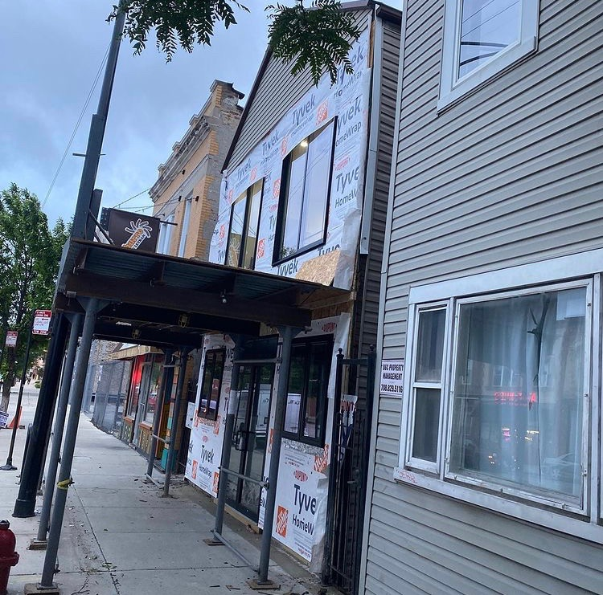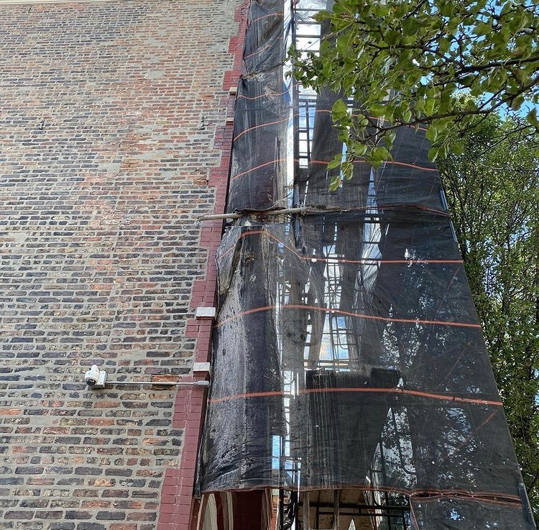
These two images depict buildings undergoing redevelopment. Revitalization, development projects, and subsequent increases in property values are central components to urban renewal and gentrification, which often lead to the displacement of existing residents.

The Roles of Race and Ethnicity

In the context of neighborhood revitalization and displacement, Curran frames gentrification as “a claim to space” (2018, p.1725). Discussions of race and ethnicity and the roles they play in the process of gentrification must by situated within the context of this notion of a “claim to space.” Kirkland (2008) argues that gentrification appears to be an extension of and amplifies the system of racial residential segregation, which “was forged in this country in the early 1990s through numerous means, including outright violence, local legislation that dictated where persons of different races could reside, and neighborhood associations with techniques such as race restrictive covenants and other anti-integrations actions” (p. 27). In essence, gentrification generally entails that the people moving into a revitalized urban area tend to be white, while the residents leaving or displaced tend to be people of color (Kirkland, 2008, p. 19).
Similarly, Mumm (2017) describes gentrification as representing a racial fix— “a way for capital investors and property buyers to assign value that is artificially inflated by constant reference to whiteness in relation to people of color” (p. 114). He highlights how black- and Latino-majority neighborhoods in Chicago have steadily whitened as a result of this “racial fix,” and states that “when the fix depends on local increases in white residents and white spaces, the displacement of black and Latino residents and institutions, and the denial of black and Latino claims to space, then it relies on, rewards, and reinscribes race” (Mumm, 2017, p. 104). In essence, a spatial fix that hinges on race and ethnicity constitutes a what Mumm calls a racial fix, and there are a number of key consequences to this process, including displacement, marginalization, and alienation.
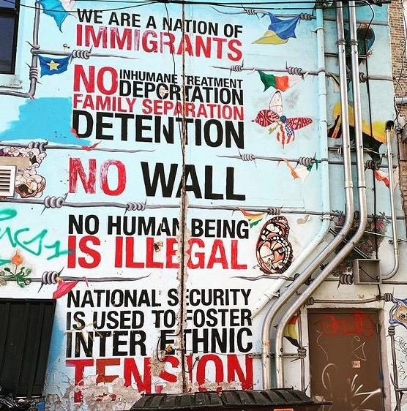
This mural depicts notions of race and ethnicity in the context of deportation and separation. This ties into Mumm’s notion of a racial fix in the sense that it directly relates to claims to space and how this fosters displacement, marginalization, isolation, and, as the image conveys, tension.

Pilsen

Anderson & Sternberg (2012) discuss the history of Pilsen—a predominantly Mexican and Mexican-American neighborhood in Chicago—and highlight how until the 1950s, Pilsen was inhabited by predominantly Eastern European immigrants (p. 450). Throughout the 1960s and 1970s, Mexican migrant workers steadily settled in Pilsen after urban renewal, highway construction, and construction of the University of Illinois at Chicago campus forced their displacement from surrounding communities (Curran, 2018, p. 1715). Anderson & Sternberg state that “by the 1980s, Pilsen had become a predominantly Latino (Mexican and Mexican-American) neighborhood and remains a sizable port of entry for Latino immigrants in Chicago” (2012, p. 450).
Over 35,000 people currently live in Pilsen, and Seif (2018) claims that “Mexican Pilsen is currently endangered” in the sense that “gentrification is displacing residents and shutting down businesses, shops, and cultural institutions” in the neighborhood (p. 67). Anderson & Sternberg highlight how Pilsen’s proximity to downtown Chicago as well as its decreased property and land values have made Pilsen increasingly attractive for developers; further, “redevelopment agents initially deployed...demonizing portrayals of Pilsen as a decrepit ghetto in need of refurbishment and colonization by affluent” White populations (2012, p. 451). These pressures and characterization of Pilsen as a neighborhood in need of change are factors that seem to justify the gentrification process.
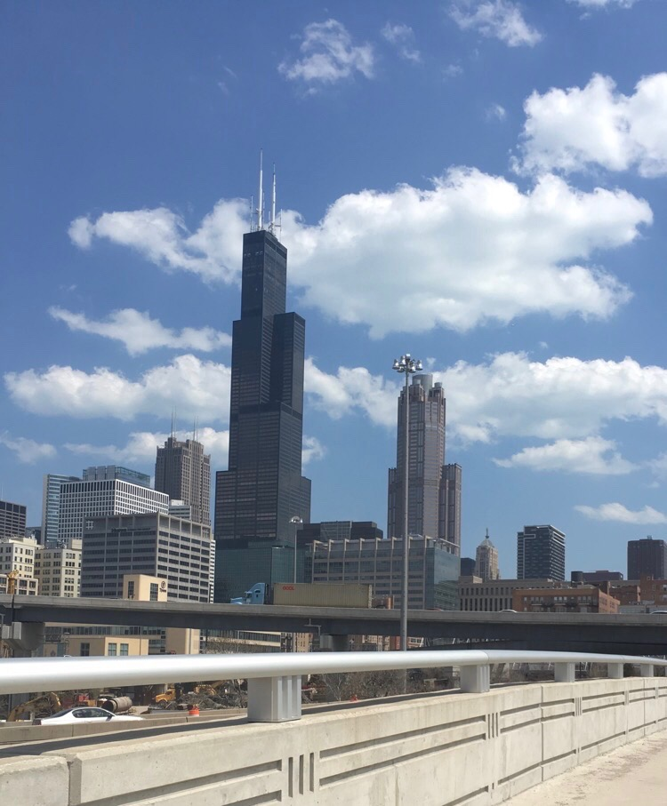
Pilsen’s proximity to downtown and the construction of highways are two factors that have made Pilsen increasingly attractive for developers and a target of gentrification. Hwang & Lin highlight job access and increasing in amenity value as two key factors central to the gentrification process and, by consequence, the displacement of existing residents (2016, p. 16).

Urban renewal efforts commenced in Pilsen throughout the 1990s and early 2000s “in the form of affluent new construction, condo conversions, trendy cafes and businesses, and the arrival of more affluent residents” (Anderson & Sternberg, 2012, pp. 451-452). Demographic and income figures demonstrate the ways in which gentrification and urban redevelopment have transformed Pilsen. Between 2000 and 2010, Pilsen’s Latino population fell from 89% to 82.4%, while Pilsen’s White population increased from 8.1% to 12.4%; further, in that same span of time, the median family income in Pilsen increased from $26,538 to $33,000 (Anderson & Sternberg, 2012, p. 443). Curran highlights the effects of displacement in other forms by discussing how household size is declining, which indicates “a replacement of larger Latinx families with singles or couples without children” (2018, p. 1717).

Significance and Consequences of Gentrification in Pilsen

Anderson & Sternberg discuss displacement within the context of median housing prices. They highlight that the median housing price in Pilsen rose from $145,000 in 2001 to $295,000 in 2006 (Anderson & Sternberg, 2012, p. 456). By consequence of this increased price of housing, Anderson & Sternberg state that “low-income Latino residents...continue to be displaced westward to disinvested Little Village and as far as suburban Cicero and Berwyn” (2012, p. 456).
Kirkland discusses displacement of existing residents as being a central effect and consequence of gentrification efforts, but also introduces notions of marginalization, isolation, and alienation—“wherein original residents remain in gentrified neighborhoods, but through the transformation of their neighborhoods, their quality of life is diminished” (2008, p. 20). The destruction of affordable housing for the purpose of urban renewal and revitalization uproots existing residents and displaces them from their homes, businesses, and communities. Curran highlights how displacement stemming from gentrification is often characterized by the loss of: (1) culture, (2) public space, (3) cultural capital, (4) social networks, (5) job opportunities, (6) commercial landscapes, and (7) “the ability to participate in neighborhood processes” (2018, pp. 1712-1713). In this way, Curran conveys how notions of displacement apply not only to physical displacement of members of a community, but also to the social character of a neighborhood (2018, p. 1713).
Curran states that transforming and revitalizing neighborhood landscapes is often presented as being beneficial to all residents of a particular neighborhood (2018, p. 1714). However, Betancur (2011) highlights the vulnerability of low-income groups and discusses the vital nature of support networks and social fabrics; he states that “limited in their mobility and exchange value resources, lower-income groups depend on such fabrics far more than do the higher income” in the sense that “they have fewer choices and are most vulnerable to place-based shifts” (p. 412). Displacement dismantles these fabrics. Framing neighborhoods, such as Pilsen, as places in need of change ignores or undermines the sense of community, belonging, and mutual support that many already marginalized, residents of low-income neighborhoods rely on, therefore potentially serving as a seedbed or amplifying a host of social and structural issues, such as further marginalization and deprivation in both a social and an economic sense.

Resistance to Gentrification in Pilsen
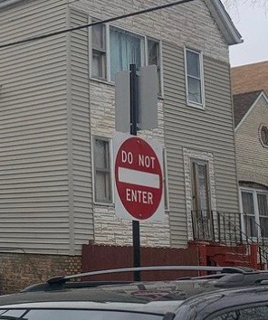
This image is meant to serve as a metaphor and symbolize firm resistance to gentrification. Resistance efforts put forth by community-based organizations and activists have helped slow the gentrification in Pilsen.

Compared to Chicago neighborhoods such as Lakeview and Lincoln Park, gentrification continues to be slower and strongly resisted (Betancur, 2011, p. 390). One means by which communities resist gentrification is through grassroot activism. Curran highlights how one particular grassroots group—the Pilsen Alliance—has put democracy to work via the use of ballot referendums as a way to challenge neighborhood renewal projects and demand transparency; the results of these processes “show community resistance to the way gentrification is happening in Pilsen” (2018, pp. 1720). However, Curran also points out that “gentrification is not a democratic process” (2018, p 1720).
That said, resistance posed by activist groups and members of communities contest gentrification and help slow the process. One consequence of resistance is polarization between gentrifiers and community organizations over the “right to place;” between these two entities are other entities, foundations, or government stakeholders that influenced outcomes via policy choices as well as the distribution or withholding of funding and resources (Betancur, 2011, p. 397). Betancur states that “ultimately, gentrification undermine[s] or neutralize[s] grassroots institutions; it open[s] wedges among residents and non-profits weakening ethnic compacts and their ability to represent the collective” (2011, p. 398). In essence, the polarization that stems from resistance to gentrification pits people and organizations against one another, and breeds dissent.
Similarly, Curran asserts that “gentrification attempts to silence dissent and marginalize those who do not conform to the new norms of the neighborhood” (2018, p. 1725). Although gentrification is not a democratic process, Curran highlights the vital nature of resistance to gentrification. Curran states that “door knocking, community meetings, ballot referendums, media coverage and electoral politics can all be marshalled as tools to demonstrate what a democratic vision for the neighborhood looks like” (2018, p. 1726). In short, resistance has an effect on combatting gentrification efforts.
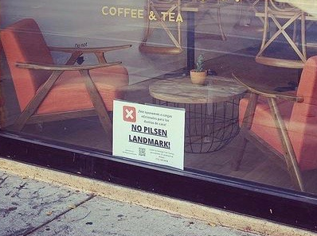
This image depicts one form of resistance in the form of signage. This sign was posted in the front window of a local coffee shop, argues for “No Pilsen Landmark.”

Resistance: The Role of Art

Notions of community and identity are central to efforts to resist gentrification. Curran highlights “Pilsen’s strong Mexican identity as a powerful tool in the ‘save community’ discourse at play” in combatting gentrification in Pilsen, and this notion of identity is made visible through murals and various other forms of street art (2018, p. 1715). In this way, art is used to celebrate ethnic identity as well as culture and community. Wilson, Wouters, & Grammenos (2004) highlight how gentrification in Pilsen has been slowed down but not defeated and that key stakeholders continue to strike against various forms of resistance (p. 1187). They discuss “the politics of murals and slogans” as being tools to combat gentrification (Wilson et al., 2004, p. 1188).
Similarly, with regard to resistance strategies, Zilberstein identifies “art as a protest tool” (2019, p. 1157). Notions of space and the right to space are imperative to discussions of art as a form of resistance. Zilberstein discusses notions of private compared to public space and states that, with the emergence of gentrification and subsequent marginalization, “public spaces become limited, and private spaces and boundaries between groups enhanced,” and continues to claim that the political elite and the economic elite benefit, whereas other non-elite groups feel excluded and alienated from formerly dominant spaces (2019, p. 1143). To grassroot, community-focused art organizations, space “served as a shared and public resource aimed to diminish social divides, rather than maintain exclusivity or privatization” (Zilberstein, 2019, p. 1153).
In the context of identity, Zilberstein (2019) highlights the “symbolic significance of...murals” (p. 1142). Many murals represent Mexican-American populations, while others depict key figures, such as Frida Kahlo (Zilberstein, 2019, p. 1156). “By articulating history and presenting spatial symbols that contest powerful actors, grassroots art gives visibility to cultural and political claims that contends with hegemonic interests” (Zilberstein, 2019, p. 1159). Community-centered artists and organizations in Pilsen seek to “preserve space in which counter-hegemonic groups can survive”
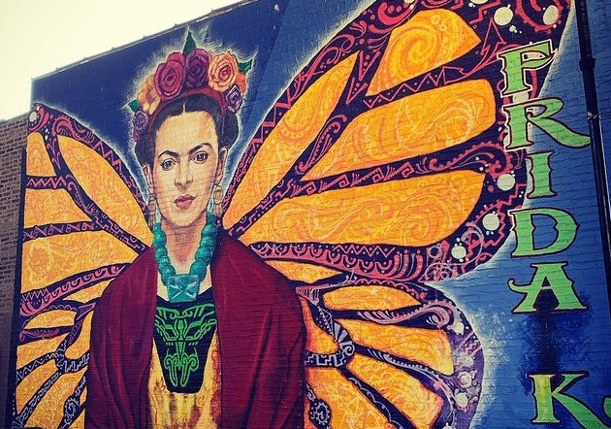
This is a mural of Mexican painter Frida Kahlo. Notions of community and identity are central to efforts to combat and resist gentrification.

Conclusion

In this photo essay, I examined gentrification efforts in Pilsen. The gentrification process uproots existing residents and displaces them from their homes, businesses, and communities, and amplifies marginalization, isolation, and alienation amongst remaining community members. Framing neighborhoods, like Pilsen, as places in need of change discredits and undermines the sense of community, belonging, and mutual support upon which many already marginalized, residents of low-income neighborhoods rely.
In the first section of this essay, I introduced gentrification and provided definitions and background of the term. In the second section, I introduced Mumm’s (2017) notion of gentrification as “a racial fix” in order to discuss the role race and ethnicity play with regard to gentrification. In the third section, I introduced Pilsen as the area of focus for this essay and provided a background of Pilsen’s history. In the fourth section, I discussed the significance and consequences of gentrification in Pilsen, namely in terms of displacement as well as marginalization, isolation, and alienation. Finally, I examined various forms of resistance to gentrification that are employed in Pilsen; I centered this section on the work of activists and grassroots organizations as well as the role of art.

References

Anderson, M. B. & Sternberg, C. (2012). “Non-white” gentrification in Chicago’s Bronzeville and Pilsen: Racial economy and the intraurban contingency of urban redevelopment. Urban Affairs Review, 49(3), 435-467.

Bader, M. D. M. (2011). Reassessing residential preferences for redevelopment. City & Community, 3(10), 311-337.

Betancur, J. (2011). Gentrification and community fabric in Chicago. Urban Studies, 48(2), 383-406.

Curran, W. (2018). ‘Mexicans love red’ and other gentrification myths: Displacements and contestations in the gentrification of Pilsen, Chicago, USA. Urban Studies, 55(8), 1711-1728.

Hwang, J. & Lin, J. (2016). What have we learned about the causes of recent gentrification? Cityscape, 18(3), 9-26.

Kirkland, E. (2008). What’s race got to do with it? Looking for the racial dimensions of gentrification. The Western Journal of Black Studies, 32(2), 18-30.

Mumm, J. (2017). The racial fix: White currency in the gentrification of black and Latino Chicago. Focaal, 79, 102-118.

Seif, H. (2018). Visualizing spaces of empowerment in Chicanx/Mexicanx Chicago with artist and cultural organizer Diana Solís. Diálogo, 21(1), 67-80.

Wilson, D., Wouters, J., & Grammenos, D. (2004). Successful protect-community discourse: Spatiality and politics in Chicago’s Pilsen neighborhood. Environmental Planning A, 36(7), 1173-1190.

Zilberstein, S. (2019). Space making as artistic practice: The relationship between grassroots art organizations and the political economy of urban development. City & Community, 18(4), 1142-1161.

